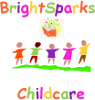
2 free settling-in sessions
at Bright sparks childcare
With this voucher.

This voucher entitles you to 2 free settling
Sessions of a maximum of 3 hours each,
for one child under the age of 5 Years

Only one voucher may be used per child.
This voucher is non-transferrable and
Has no cash value.

Valid until Friday 18th July 2014

