

**Colouring In Book**

71 Stott Close

Efford

PL3 6HA

(01752) 225 115

[brightsparks@live.co.uk](mailto:brightsparks@live.co.uk)

www.brightsparkschildcare.co.uk

**Minibeast**



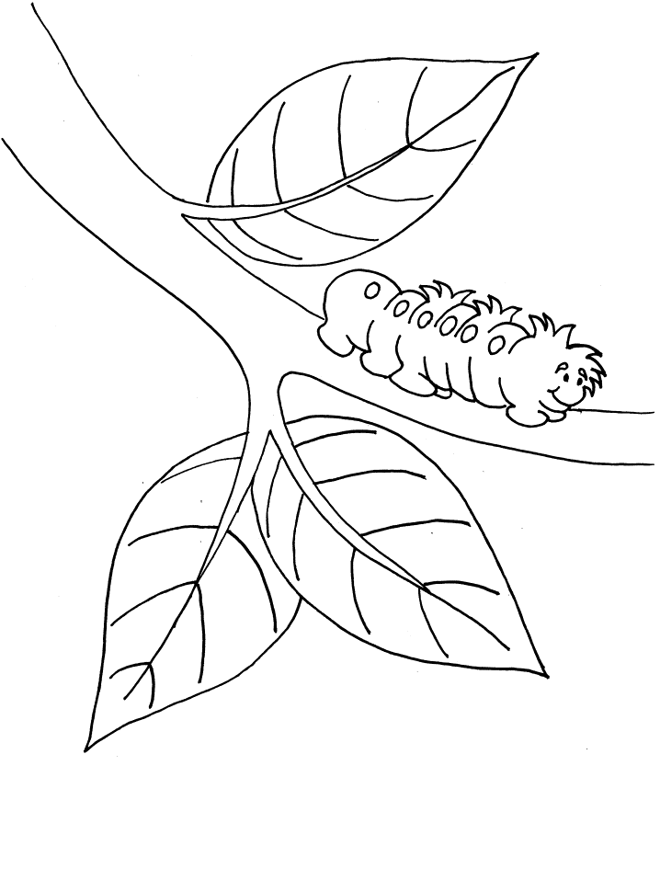

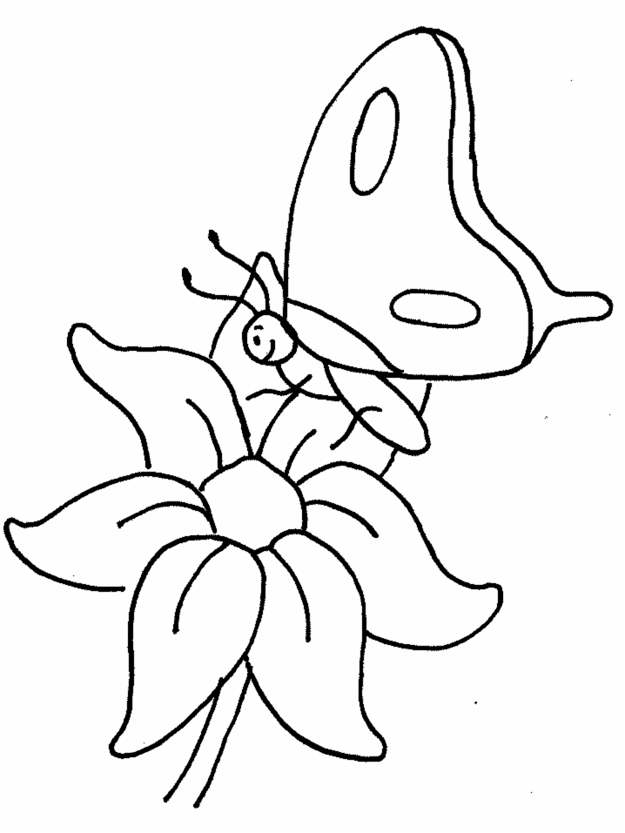

71 Stott Close

Efford

PL3 6HA

(01752) 225 115

[brightsparks@live.co.uk](mailto:brightsparks@live.co.uk)

www.brightsparkschildcare.co.uk



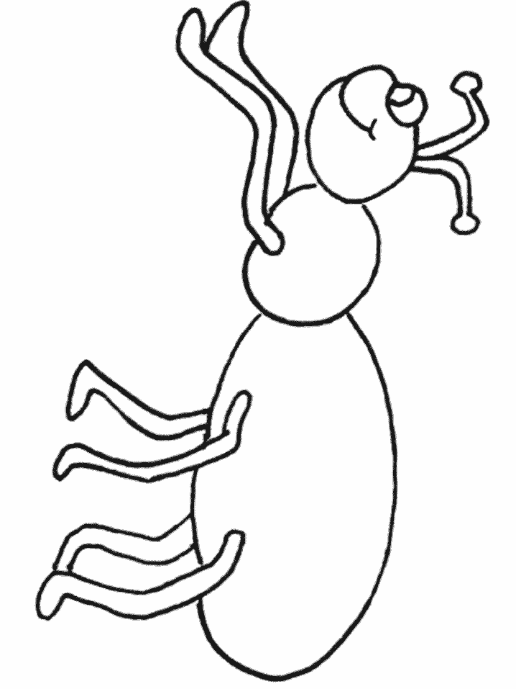

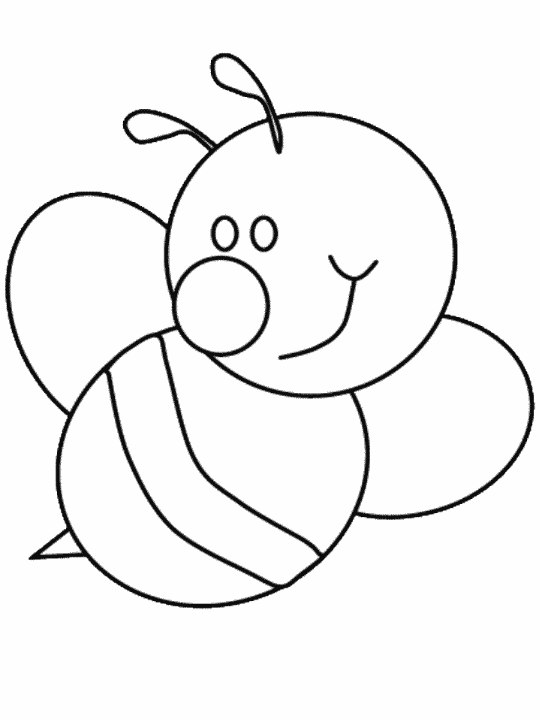

71 Stott Close

Efford

PL3 6HA

(01752) 225 115

[brightsparks@live.co.uk](mailto:brightsparks@live.co.uk)

www.brightsparkschildcare.co.uk



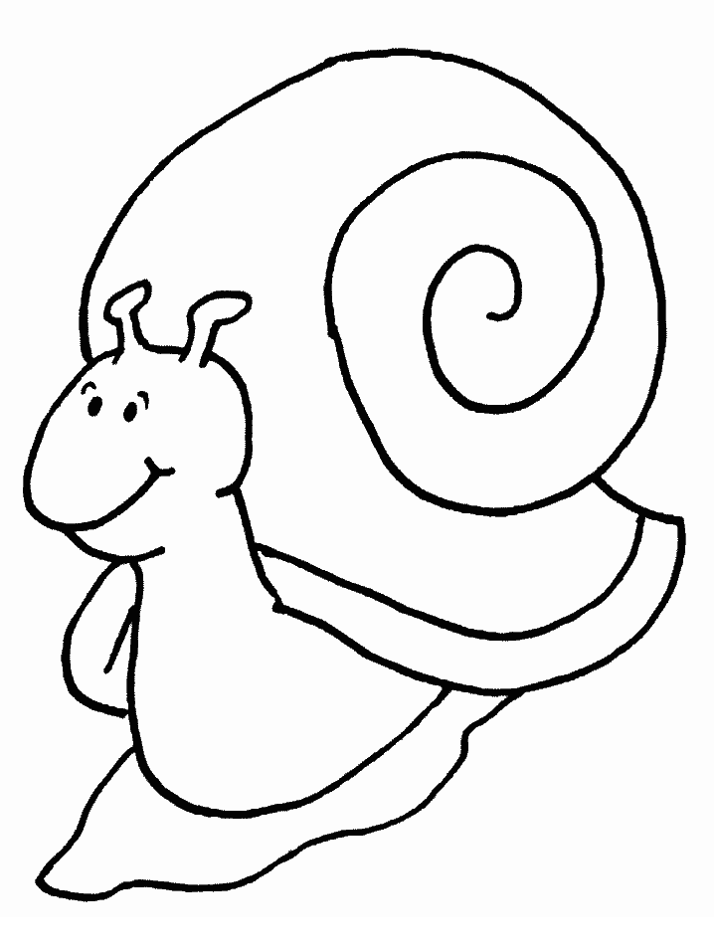



71 Stott Close

Efford

PL3 6HA

(01752) 225 115

[brightsparks@live.co.uk](mailto:brightsparks@live.co.uk)

www.brightsparkschildcare.co.uk



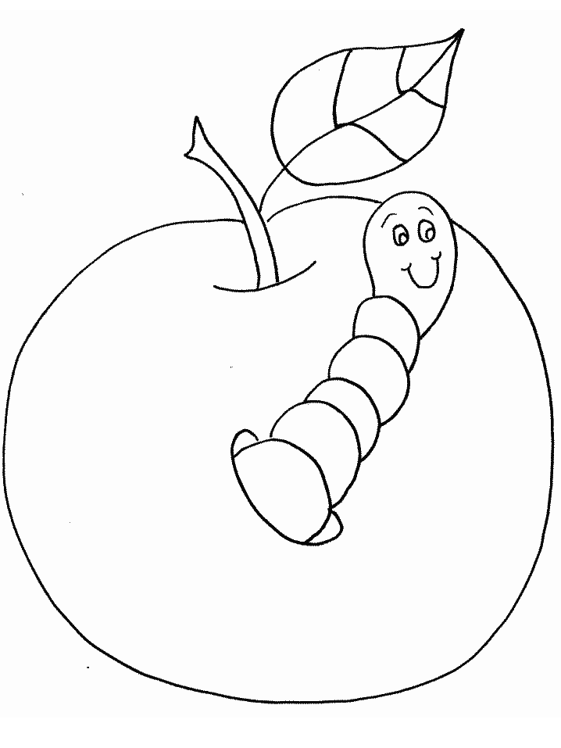

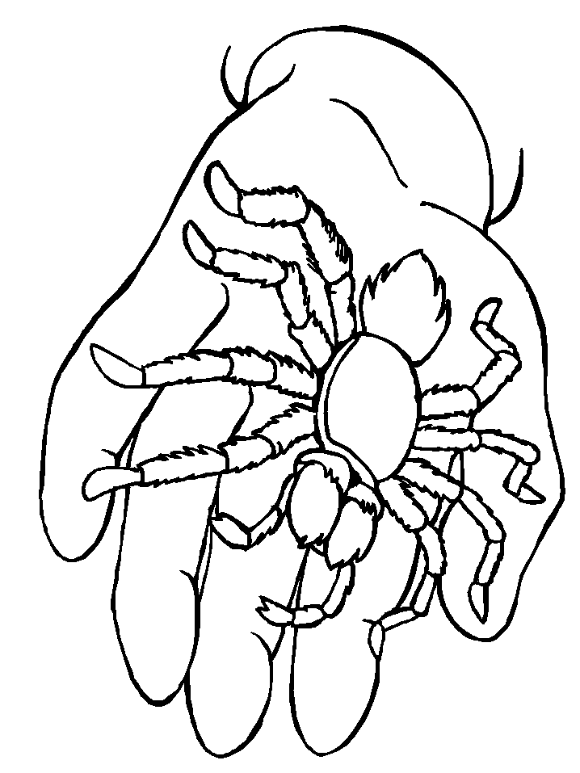

71 Stott Close

Efford

PL3 6HA

(01752) 225 115

[brightsparks@live.co.uk](mailto:brightsparks@live.co.uk)

www.brightsparkschildcare.co.uk



71 Stott Close

Efford

PL3 6HA

(01752) 225 115

[brightsparks@live.co.uk](mailto:brightsparks@live.co.uk)

www.brightsparkschildcare.co.uk

