


71 Stott Close
Efford
PL3 6HA
Phone: (01752) 225 115
Email: brightsparks@live.co.uk
Visit our website at:
www.brightsparkschildcare.co.uk
COLOURING BOOK




71 Stott Close, Efford, PL3 6HA
Phone: (01752) 225 115
Email: brightsparks@live.co.uk
Visit our website at: www.brightsparkschildcare.co.uk




71 Stott Close, Efford, PL3 6HA
Phone: (01752) 225 115
Email: brightsparks@live.co.uk
Visit our website at: www.brightsparkschildcare.co.uk

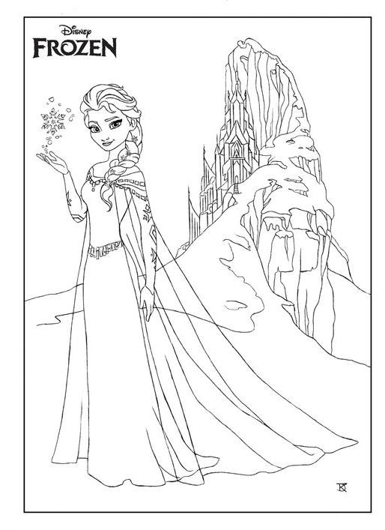

/
71 Stott Close, Efford, PL3 6HA
Phone: (01752) 225 115
Email: brightsparks@live.co.uk
Visit our website at: www.brightsparkschildcare.co.uk




71 Stott Close, Efford, PL3 6HA
Phone: (01752) 225 115
Email: brightsparks@live.co.uk
Visit our website at: www.brightsparkschildcare.co.uk




71 Stott Close, Efford, PL3 6HA
Phone: (01752) 225 115
Email: brightsparks@live.co.uk
Visit our website at: www.brightsparkschildcare.co.uk



71 Stott Close, Efford, PL3 6HA
Phone: (01752) 225 115
Email: brightsparks@live.co.uk
Visit our website at: www.brightsparkschildcare.co.uk



71 Stott Close, Efford, PL3 6HA
Phone: (01752) 225 115
Email: brightsparks@live.co.uk
Visit our website at: www.brightsparkschildcare.co.uk

